How To Create Drawable Resource XML File in Android Studio
Drawable Resource XML is mostly created in drawable folder and is used in Android to add more customization for views. Here are step by step how to create new Drawable Resource XML in Android Studio.

How To Create Drawable Resource XML File in Android Studio:
Step 1: Firstly, Right Click on drawable as shown in figure below.
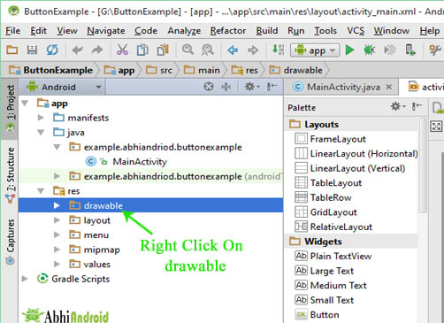
Step 2: After that Go New > Drawable resource file as shown in figure below.
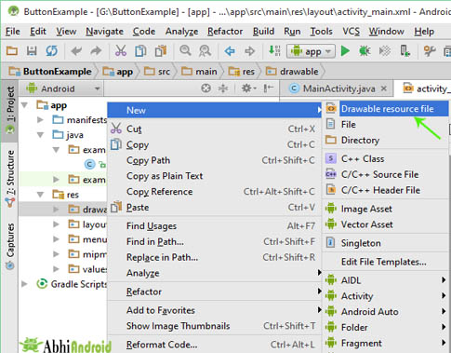
Step 3: After that New Resource file dialog box open on your computer screen. Enter File name in the text box and then press OK. Here File name is custom_button.
Important Note: File names must start with a lowercase letter.
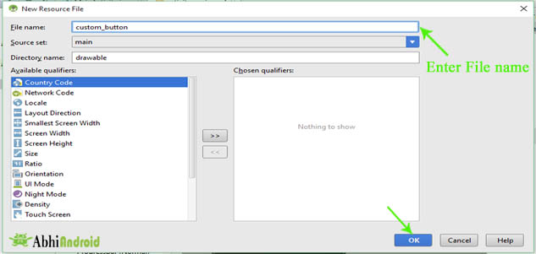
Step 4: After that your drawable resource XML file will be created as shown in figure below.
